
MEK1 (D67N)
Catalog Number:CR-M26224
Gene Symbol: MAP2K1; MAPKK1; MEK1; MKK1; PRKMK1 Description: Anti-MEK1 (D67N) Mouse Monoclonal Antibody

Background: MEK1 (also known as
extracellular signal-regulated kinases, ERKs)
plays important role in the MAP kinase cascade, which transduces multiple extracellular signals to control cell growth, proliferation and
differentiation. Activated upon growth factors stimulation, MEK1 phosphorylates
MAPK3/ERK1 and MAPK1/ERK2, thus
activates the MAP pathway and regulates
transcription. Abnormal of the MEK1 protein,
including point mutations, are implicated in
diseases such as cardiofaciocutaneous syndrome (CFC) and melanoma.
Immunogen: A synthetic peptide from the internal region of MEK1 which includes the mutation of D67N, human origin.
Tested applications: ELISA, WB, IHC Recommended dilutions:
ELISA: 1:1000-1:2000
WB: 1:500-1:1000
IHC: 1:50-1:100
Concentration: 1 mg/ml
Host: Mouse
Clonality: Monoclonal
Purity: Purified from ascites
Format: Liquid Storage buffer:
Preservative: no
Constituents: PBS (without Mg2+ and Ca2+), pH 7.4, 150 mM NaCl, 50% glycerol
Species Reactivity: Recognizes D67N mutant, but not wild-type MEK1 of vertebrates.

Storage Conditions: Store at -20°C. Avoid freeze / thaw cycles.
Western blot:
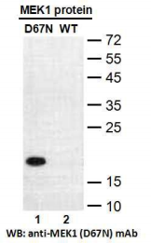
Western blot analysis of recombinant MEK1 (D67N) and wildtype proteins. Purified
His-tagged MEK1 (D67N) protein (lane 1) and corresponding wildtype protein (lane 2) were blotted with anti-MEK1 (D67N) monoclonal
antibody (Cat. #26224).

For research use only. Not for diagnostic or therapeutic applications.

Immunofluorescence:
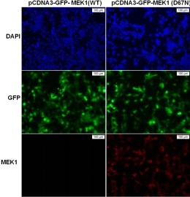
Immunofluorescence of cells expressing MEK1 proteins with anti-MEK1 (D67N) antibody.
HEK293T cells were transfected with
pCDNA3-GFP-MEK1 (WT) plasmid (left
column) or pCDNA3-GFP-MEK1 (D67N)
plasmid (right column), then fixed and stained with anti-MEK1 (D67N) monoclonal antibody (Cat. #26224).

科博瑞（武汉）生物科技有限公司
TEL：027-87615885 15972062685
- mail：3636901710@qq.com
Web:www.coburybio.com

